INF 286 Instructor Dr. Seth Adjei
Assignment #6 Last Name: First Name:

Grade:
Comment:
Assignment 6: More on Links, Lists, and Mobile
Problem 1 Create a web page about yourself (screen display and print preview of an example Web page are shown below), which satisfies the following requirements:
- It is linked with two external css files. One is for screen display and the other is for print. The print version of the web page does not show the navigation and the image in the header section (10%).
- The web page includes a top header and three columns: the left navigation column, the right sidebar column and the center main text column (20%);
- The web page is centered and occupies 80% of the available browser window width (5%);
- The top header section includes:
  - The logo text for your webpage and (5%);
  - A logo image on the right end (5%);.
- The left column is the navigation area, which includes five navigation hyperlinks to home, bio, Classes, Favorite web sites, and contact (10%);
- The navigation links should work as required:
  - Do not show list markers and underlines (5%);
  - Have different colors at different states (5%).
- The right sidebar column includes:
  - At least two news items with titles (10%);
- The center main text column includes:
  - A main content area shows some text and an image (15%);
  - A footer area indicating your copy right (5%).
- Paste the screen shot when Print-Previewing the web page and the screen shot of the web page display on screen (5%).

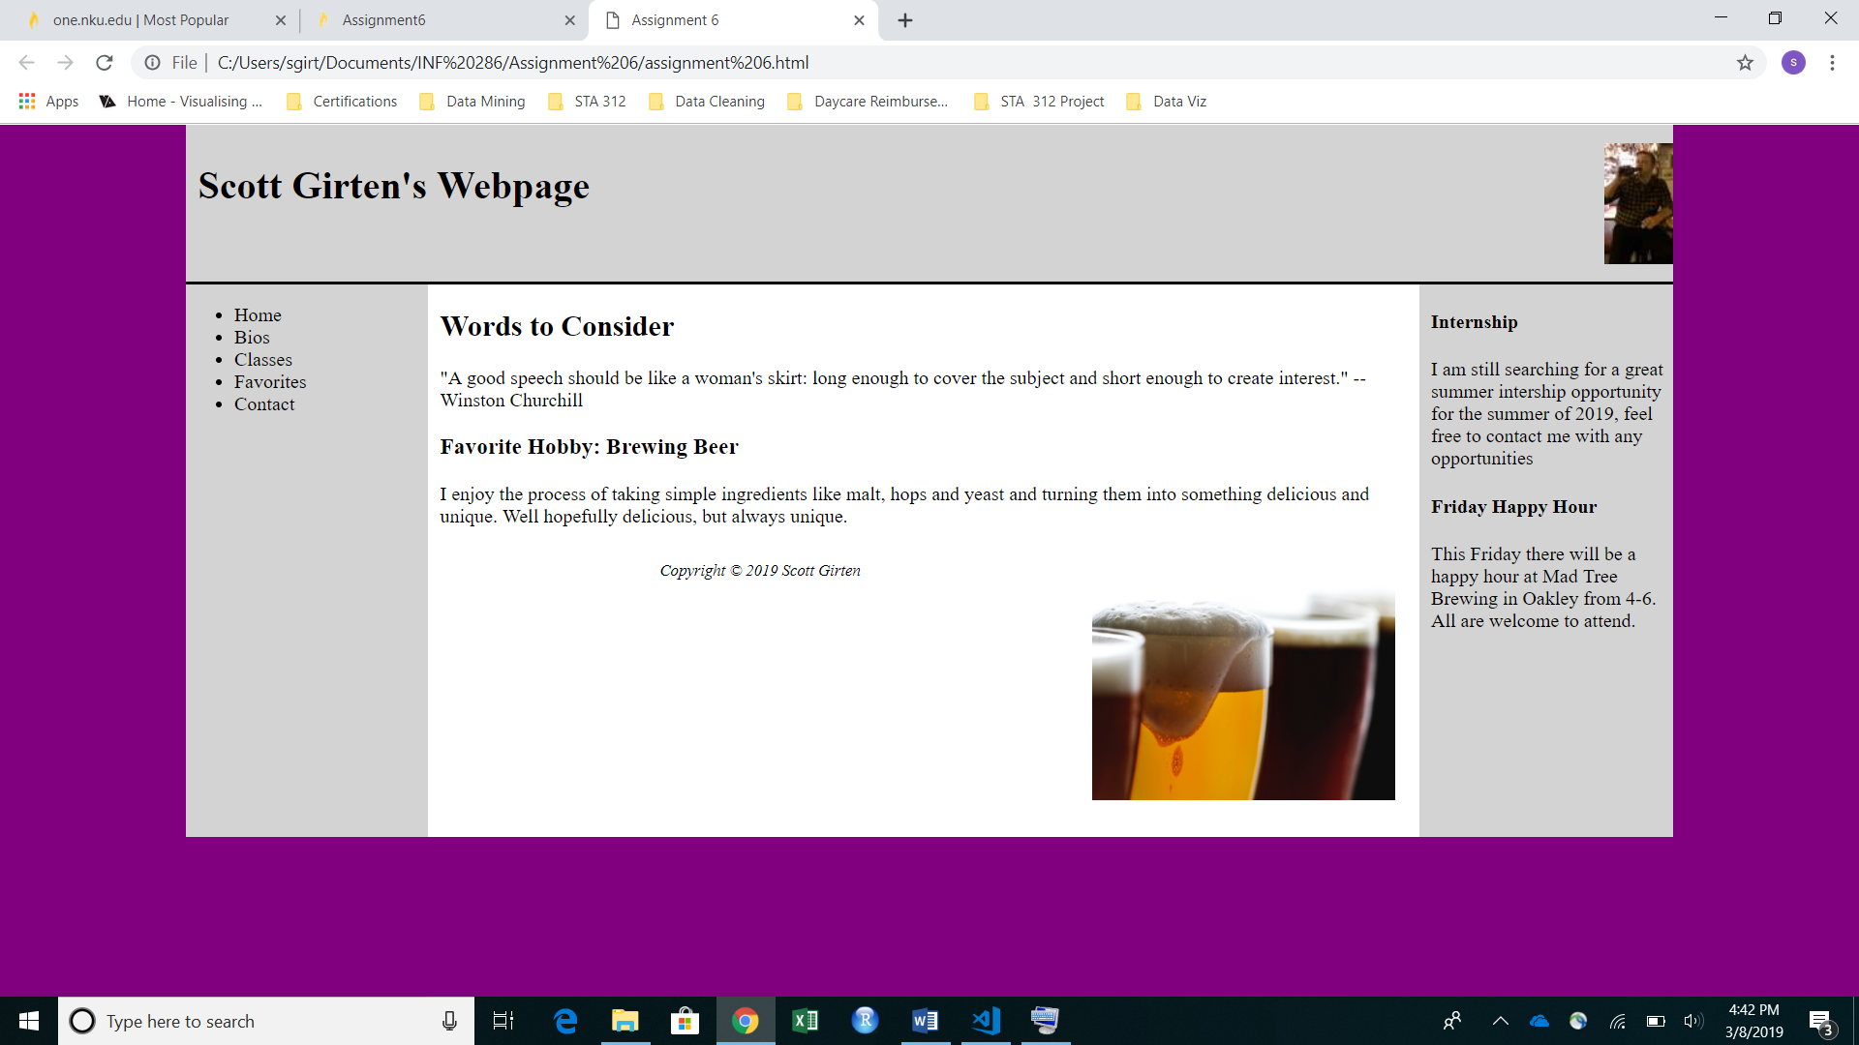

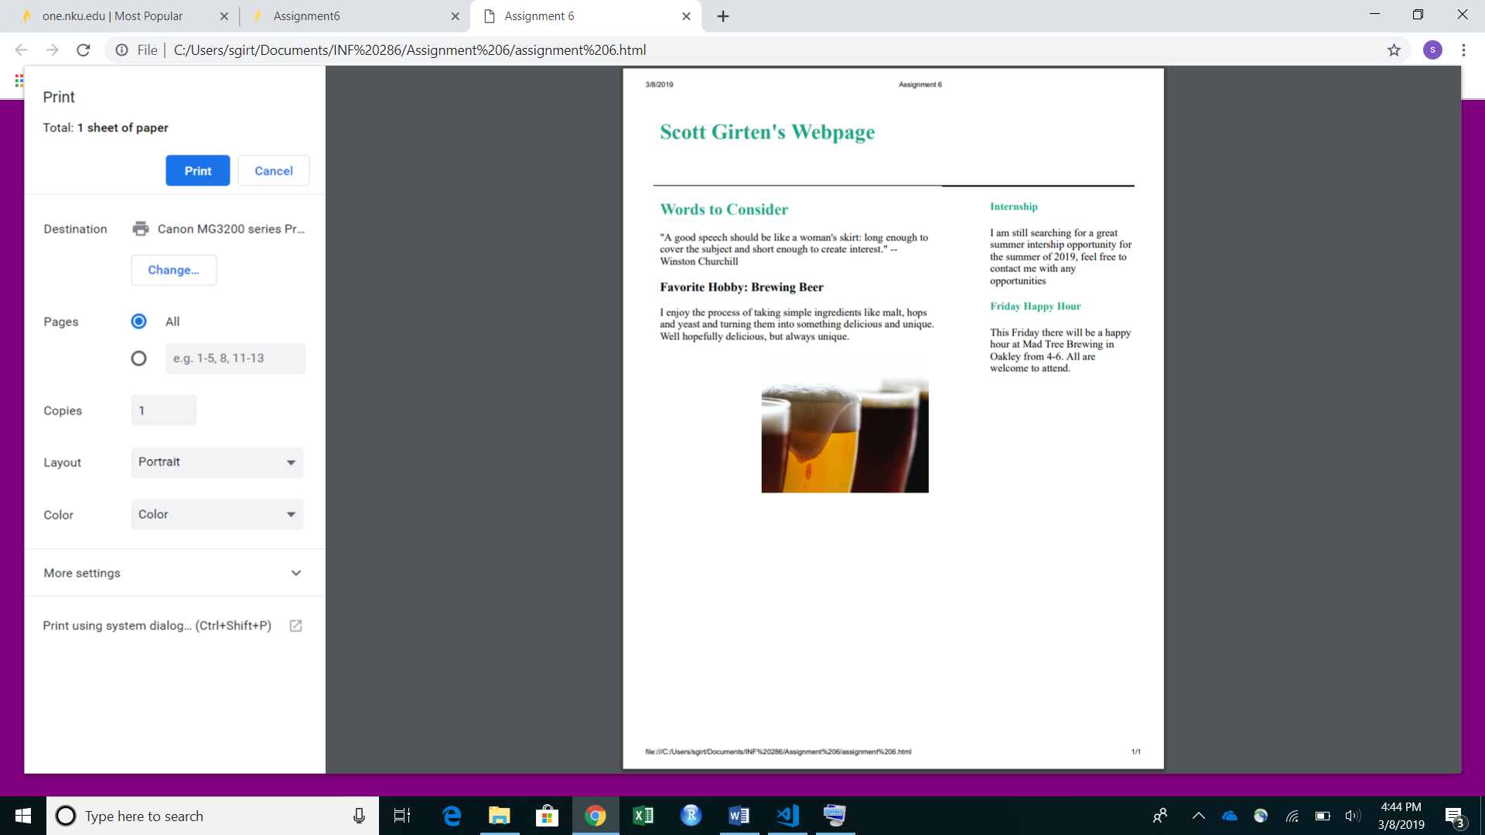
- Please save your web page file (html file) and associated files (image files and css files) in a folder named YourLastName_FirstName_assignment_6 and compress this folder as YourLastName_FirstName_assignment_6.zip for submission in Canvas.

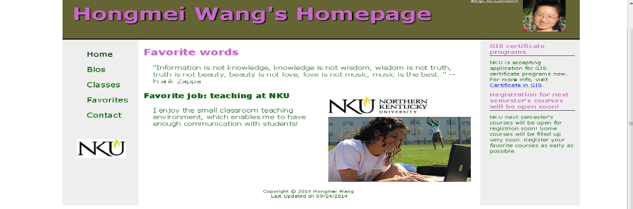

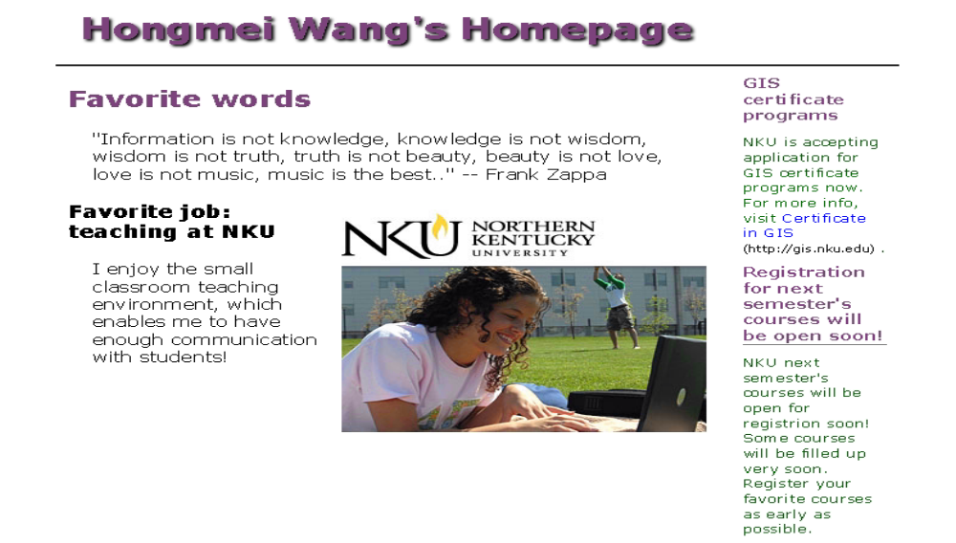
Note:
- Submit YourLastName_YourFirstName_Assignment6.zip file to Canvas.

